DAY-26 & 27(13/8/2025) & (14/8/2025)
Emp ID : 110714877
NAME :Kinnera venkatamma

Task 01:What are the Advantages of Multi tier Architecture?

The advantages of a multi-tier architecture are improved scalability, where each tier can be scaled independently to meet demand; enhanced maintainability and flexibility due to the separation of concerns; better security by isolating tiers and controlling data access; and increased reliability, as an issue in one tier is less likely to impact others.

Additionally, it allows for faster development cycles as teams can work on different tiers simultaneously, and it can lead to higher performance through optimized resource utilization and caching at specific tiers.

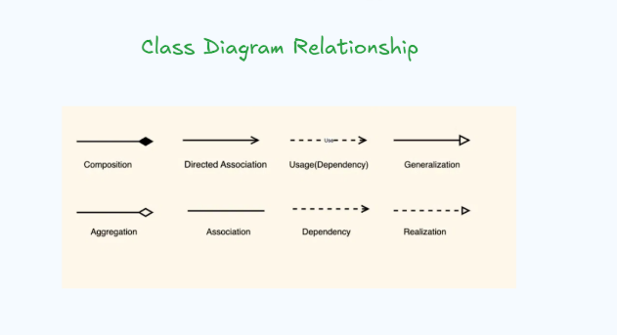

Task:
Create a package diagram representation of Command Design Pattern code..

package "CommandPattern" {
package "commands" {
class Command <<interface>>
class ConcreteCommandA implements Command
class ConcreteCommandB implements Command
}

package "invoker" {
class Invoker
}

package "receiver" {
class Receiver
}

package "client" {
class Client
}

"commands" ..> "receiver" : uses
"invoker" ..> "commands" : holds
"client" ..> "invoker" : creates and sets
"client" ..> "commands" : creates
"client" ..> "receiver" : creates
}

Create uml diagrams to represent different kinds of relation ships

UML (Unified Modeling Language) diagrams represent relationships between elements using specific notations. The primary types of relationships depicted in UML class diagrams are:

Association: Represents a structural relationship where objects of one class are connected to objects of another. It is typically shown as a solid line between two classes.

+-----------------+ +-----------------+
| ClassA |--------| ClassB |
+-----------------+ +-----------------+

Multiplicity: Can be added to indicate the number of instances involved (e.g., 1 for one, * for many, 1..* for one or more).

+-----------------+ +-----------------+
| ClassA |--1----| ClassB |
+-----------------+ +-----------------+

Navigability: An arrow can be added to indicate the direction of the relationship if one class knows about the other, but not vice versa.

+-----------------+ +-----------------+
| ClassA |------->| ClassB |
+-----------------+ +-----------------+

Aggregation: A "has-a" relationship representing a whole-part relationship where the part can exist independently of the whole. It is shown with a hollow diamond at the "whole" end and a line to the "part" end.

+-----------------+ +-----------------+
| Whole |<>- - - -| Part |
+-----------------+ +-----------------+

Composition: A stronger "has-a" relationship than aggregation, where the part cannot exist without the whole. It is shown with a filled diamond at the "whole" end and a line to the "part" end.

+-----------------+ +-----------------+
| Container |<*>- - - -| Component |
+-----------------+ +-----------------+
Generalization (Inheritance): Represents an "is-a" relationship where a subclass inherits properties and behaviors from a superclass. It is shown as a solid line with a hollow arrowhead pointing from the subclass to the superclass.

+-----------------+
| SuperClass |
+-----------------+
^
|
+-----------------+
| SubClass |
+-----------------+
Dependency: Indicates that a change in one class might affect another, but it's not a direct structural relationship like association. It's often used for "uses" or "depends on" relationships. It is shown as a dashed line with an open arrowhead pointing from the dependent class to the independent class.

+-----------------+ +-----------------+
| Client | - - - ->| Service |
+-----------------+ +-----------------+
Realization (Implementation): Represents the relationship between an interface and a class that implements it. It is shown as a dashed line with a hollow arrowhead pointing from the implementing class to the interface.

+-----------------+ +-----------------+
| Interface |<-- - - -| ClassImpl |
+-----------------+ +-----------------+

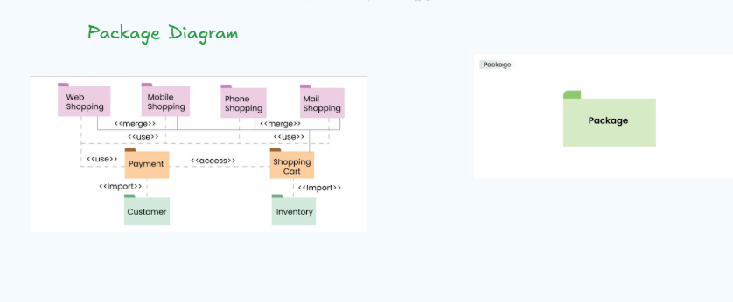

MCQ’S practiced- day 27

